Triangular Wedge

Definition
# Source: AI Source: Provided by: [Data Path: Persons Table -> ID Column: 1, Name_En Column: Motasem Essam] -> From: [ChatGPT] on [7/25/2026]
A Triangular Wedge is a three-dimensional geometric solid with a triangular cross-section and a length extending in a direction perpendicular to that cross-section. In its common form, it is a triangular prism: it has two parallel, congruent triangular ends connected by three rectangular lateral faces.
It is called a wedge because its shape resembles a doorstop or a tapered block.
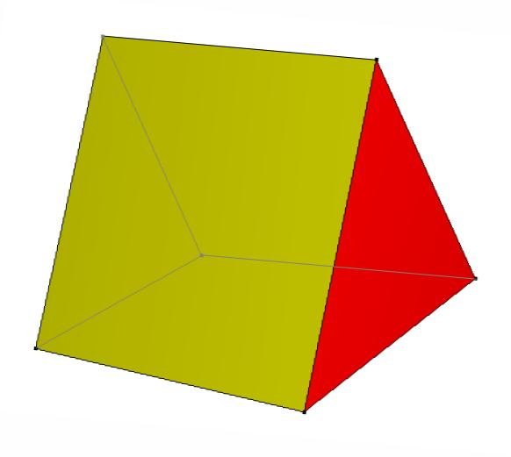
Triangular wedge – 3D geometric representation.
Important distinction: In solid geometry, a triangular wedge is not necessarily the same as a triangular prism. A general wedge has two triangular faces and three quadrilateral faces, often trapezoids. A triangular prism instead has two congruent triangular ends and three rectangular side faces.

Simple Definition
# Source: AI Source: Provided by: [Data Path: Persons Table -> ID Column: 1, Name_En Column: Motasem Essam] -> From: [ChatGPT] on [7/25/2026]
A triangular wedge is a polyhedron formed by two triangular end faces joined by three quadrilateral lateral faces. Its shape resembles a block that becomes thinner or changes height along its length.
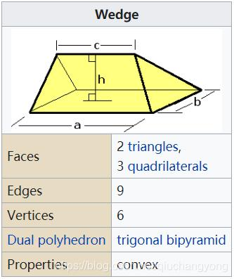

Geometric Structure
# Source: AI Source: Provided by: [Data Path: Persons Table -> ID Column: 1, Name_En Column: Motasem Essam] -> From: [ChatGPT] on [7/25/2026]
A general triangular wedge has the following main components:
- Two triangular faces: The two triangular ends of the solid.
- Three lateral faces: Quadrilateral faces connecting corresponding edges of the triangular ends.
- Six vertices: Three vertices on each triangular end.
- Nine edges: Three edges on each triangular end and three connecting edges.

Face Structure
# Source: AI Source: Provided by: [Data Path: Persons Table -> ID Column: 1, Name_En Column: Motasem Essam] -> From: [ChatGPT] on [7/25/2026]
A triangular wedge has 5 faces.
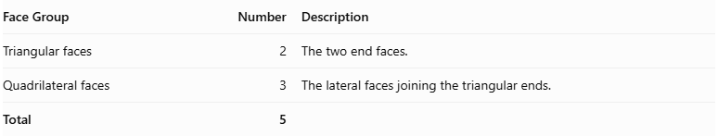
Face Group | Number | Description
Triangular faces | 2 | The two end faces.
Quadrilateral faces | 3 | The lateral faces joining the triangular ends.
Total | 5
In a general wedge, the three lateral faces may be trapezoids. In special arrangements, some may be parallelograms or rectangles.
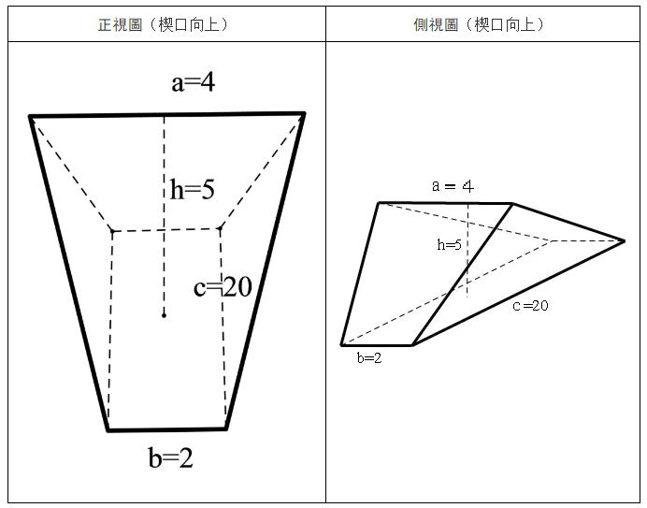

Edge Structure
# Source: AI Source: Provided by: [Data Path: Persons Table -> ID Column: 1, Name_En Column: Motasem Essam] -> From: [ChatGPT] on [7/25/2026]
A triangular wedge has 9 edges.
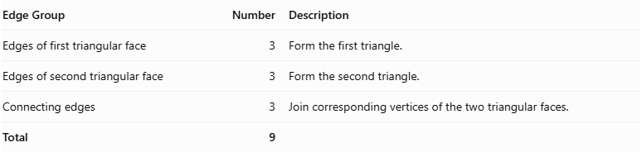
Edge Group | Number | Description
Edges of first triangular face | 3 | Form the first triangle.
Edges of second triangular face | 3 | Form the second triangle.
Connecting edges | 3 | Join corresponding vertices of the two triangular faces.
Total | 9

Vertex Structure
# Source: AI Source: Provided by: [Data Path: Persons Table -> ID Column: 1, Name_En Column: Motasem Essam] -> From: [ChatGPT] on [7/25/2026]
A triangular wedge has 6 vertices.
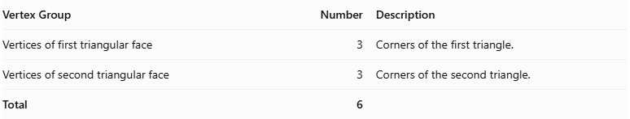
Vertex Group | Number | Description
Vertices of first triangular face | 3 | Corners of the first triangle.
Vertices of second triangular face | 3 | Corners of the second triangle.
Total | 6

Mathematical Properties
# Source: AI Source: Provided by: [Data Path: Persons Table -> ID Column: 1, Name_En Column: Motasem Essam] -> From: [ChatGPT] on [7/25/2026]
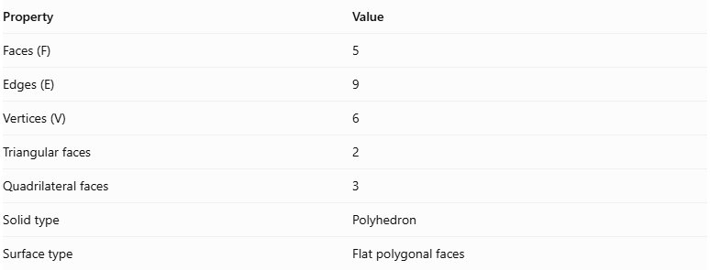
Property | Value
Faces (F) | 5
Edges (E) | 9
Vertices (V) | 6
Triangular faces | 2
Quadrilateral faces | 3
Solid type | Polyhedron
Surface type | Flat polygonal faces
It satisfies Euler's polyhedron formula:
$$V-E+F=2$$
Substituting:
$$6-9+5=2$$
Therefore, the triangular wedge satisfies Euler's formula.

Surface Area
# Source: AI Source: Provided by: [Data Path: Persons Table -> ID Column: 1, Name_En Column: Motasem Essam] -> From: [ChatGPT] on [7/25/2026]
The total surface area is the sum of the areas of its two triangular faces and three quadrilateral lateral faces.
$$\boxed{S=A_{1}+A_{2}+A_{3}+A_{4}+A_{5}}$$
Where:
- $A_{1},A_{2}$ are the areas of the two triangular faces.
- $A_{3},A_{4},A_{5}$ are the areas of the three lateral faces.
For triangular end faces, the area can be calculated using:
$$A=\frac{1}{2}bh$$
For trapezoidal lateral faces:
$$A=\frac{1}{2}(a+b)h$$
The dimensions used depend on the shape and orientation of each face.

Volume
# Source: AI Source: Provided by: [Data Path: Persons Table -> ID Column: 1, Name_En Column: Motasem Essam] -> From: [ChatGPT] on [7/25/2026]
The volume of a general triangular wedge depends on its dimensions and the arrangement of its faces.
For a wedge with a rectangular bottom of dimensions $a$ and $b$, a top edge of length $c$ parallel to side $a$, and perpendicular height $h$, the volume is:
$$\boxed{V=bh\left(\frac{a}{3}+\frac{c}{6}\right)}$$
Here, $a$, $b$, $c$, and $h$ describe this particular wedge configuration; this formula is not a universal formula for every solid called a wedge.

Relationship to Other Solids
# Source: AI Source: Provided by: [Data Path: Persons Table -> ID Column: 1, Name_En Column: Motasem Essam] -> From: [ChatGPT] on [7/25/2026]
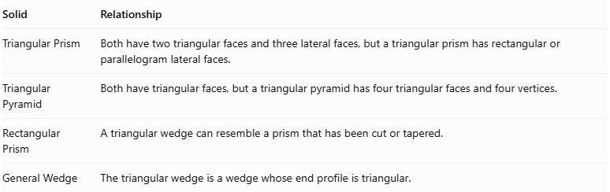
Solid | Relationship
Triangular Prism | Both have two triangular faces and three lateral faces, but a triangular prism has rectangular or parallelogram lateral faces.
Triangular Pyramid | Both have triangular faces, but a triangular pyramid has four triangular faces and four vertices.
Rectangular Prism | A triangular wedge can resemble a prism that has been cut or tapered.
General Wedge | The triangular wedge is a wedge whose end profile is triangular.
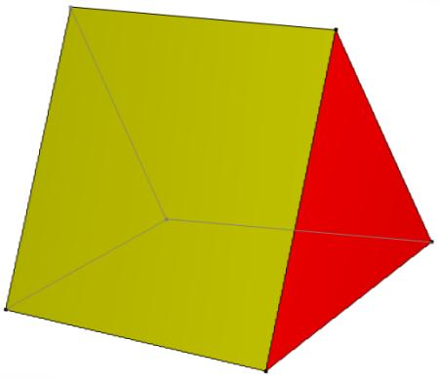

Symmetry
# Source: AI Source: Provided by: [Data Path: Persons Table -> ID Column: 1, Name_En Column: Motasem Essam] -> From: [ChatGPT] on [7/25/2026]
The symmetry of a triangular wedge depends on its dimensions and construction.
- A symmetrical triangular wedge may have a plane of reflection symmetry.
- An irregular triangular wedge may have no reflection symmetry.
- It generally does not have the rotational symmetry of a regular prism.
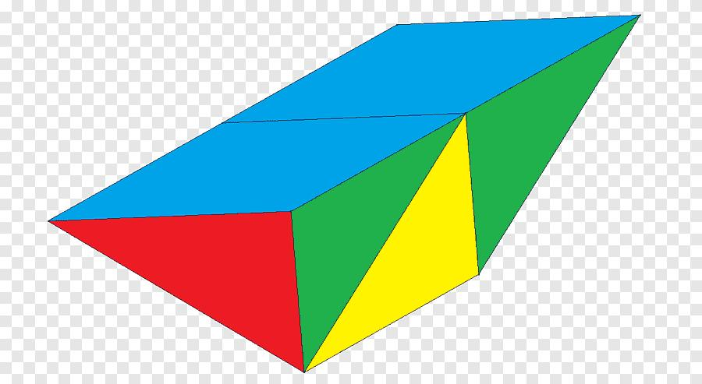

Worked Examples

Example 1: Calculate Faces, Edges, and Vertices
# Source: AI Source: Provided by: [Data Path: Persons Table -> ID Column: 1, Name_En Column: Motasem Essam] -> From: [ChatGPT] on [7/25/2026]
A triangular wedge has:
- 2 triangular faces.
- 3 quadrilateral faces.
- 9 edges.
- 6 vertices.
Therefore:
$$F=2+3=5$$
$$E=3+3+3=9$$
$$V=3+3=6$$

Example 2: Calculate Volume
# Source: AI Source: Provided by: [Data Path: Persons Table -> ID Column: 1, Name_En Column: Motasem Essam] -> From: [ChatGPT] on [7/25/2026]
Given a wedge with:
- $a=9\text{ cm}$
- $b=4\text{ cm}$
- $c=3\text{ cm}$
- $h=6\text{ cm}$
Using:
$$V=bh\left(\frac{a}{3}+\frac{c}{6}\right)$$
Substituting:
$$V=4(6)\left(\frac{9}{3}+\frac{3}{6}\right)$$
$$V=24(3+0.5)$$
$$\boxed{V=84{\text{ cm}}^{3}}$$
This example uses the particular wedge configuration described in Section 9.

Constructing Triangular Wedge in Solid Geometry

Geometric Instruments Used
# Source: AI Source: Provided by: [Data Path: Persons Table -> ID Column: 1, Name_En Column: Motasem Essam] -> From: [ChatGPT] on [7/25/2026]

- Ruler: Drawing straight edges.
- Compass: Drawing arcs and transferring distances.
- Protractor: Measuring angles.
- Set square: Drawing perpendicular and parallel lines.
- Pencil: Drawing construction lines.
- Eraser: Removing unnecessary construction marks.

Instrument-Based Construction Procedures

A. Constructing the First Triangular Face
# Source: AI Source: Provided by: [Data Path: Persons Table -> ID Column: 1, Name_En Column: Motasem Essam] -> From: [ChatGPT] on [7/25/2026]
- Draw a triangle using a ruler and protractor.
- Mark its three vertices as A, B, and C.
- Complete the triangular outline.

B. Constructing the Second Triangular Face
# Source: AI Source: Provided by: [Data Path: Persons Table -> ID Column: 1, Name_En Column: Motasem Essam] -> From: [ChatGPT] on [7/25/2026]
- Draw a second triangle in a different position.
- Mark its vertices as A′, B′, and C′.
- Make the second triangle parallel to the first one if constructing a prism-like wedge.

C. Connecting the Two Triangular Faces
# Source: AI Source: Provided by: [Data Path: Persons Table -> ID Column: 1, Name_En Column: Motasem Essam] -> From: [ChatGPT] on [7/25/2026]
- Connect vertex A to A′.
- Connect vertex B to B′.
- Connect vertex C to C′.
- Form the three lateral quadrilateral faces.

D. Completing the Triangular Wedge
# Source: AI Source: Provided by: [Data Path: Persons Table -> ID Column: 1, Name_En Column: Motasem Essam] -> From: [ChatGPT] on [7/25/2026]
- Check that the solid has two triangular end faces.
- Check that the three lateral faces connect the corresponding edges.
- Darken the visible edges.
- Draw hidden edges using dashed lines when necessary.
- Remove unnecessary construction marks.
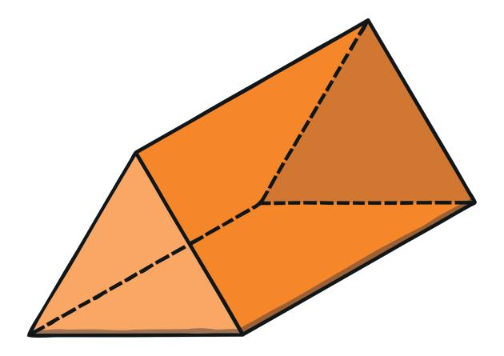

Key Points
# Source: AI Source: Provided by: [Data Path: Persons Table -> ID Column: 1, Name_En Column: Motasem Essam] -> From: [ChatGPT] on [7/25/2026]
- A triangular wedge is a three-dimensional polyhedron.
- It has two triangular faces.
- It has three quadrilateral lateral faces.
- It has 5 faces in total.
- It has 9 edges.
- It has 6 vertices.
- Its lateral faces may be trapezoids.
- Its surface area is the sum of the areas of all five faces.
- Its volume depends on the dimensions and geometric arrangement of the wedge.

Conclusion
# Source: AI Source: Provided by: [Data Path: Persons Table -> ID Column: 1, Name_En Column: Motasem Essam] -> From: [ChatGPT] on [7/25/2026]
A Triangular Wedge is a polyhedron consisting of two triangular end faces connected by three quadrilateral lateral faces. It has 5 faces, 9 edges, and 6 vertices.
Its defining characteristic is its wedge-shaped structure, which distinguishes it from an ordinary triangular prism.

